**Food Production Through Protected Cropping**

# Student Information

In this unit, you will be learning about the horticulture industry and, in particular, protected cropping. The lessons aim to develop your understanding of how the conditions for crop growth can be controlled for successful farming and about the challenges that farmers must overcome.

You will need to explore a variety of sources then apply a range of geography skills to further your understanding and improve your ability to critically analyse and understand the many factors affecting this industry.

* **Use the Answer Workbook or the Learning Journal PowerPoint to record all of your answers.**
* There is a MS Word and a PDF version of the document.
* The Learning Journal is in PPT only.

Refer to this before moving on to each new section and, where possible, to check your progress. Make any corrections with a different coloured pen or font.

**LESSON 1**

**What is Horticulture?**



**Activity 1A**

1) Follow the link to Google Maps street view.

1. <https://tinyurl.com/horticultureintro>
2. Describe all the things you can see along the street to your right (“virtually walk” along the road).

|  |  |
| --- | --- |
|  |  |
| Landscape: |  |
|  |  |
| Buildings: |  |
|  |  |
| Vegetation: |  |
|  |  |
| Number of people: |  |
|  |  |
| Equipment: |  |

2) Go out of street view to a satellite view of the same area <https://tinyurl.com/horticulturemap> Observe the size of the buildings from a zoomed-out satellite view.

1. Using the scale on the map, how large do you think the greenhouses are?
2. Approximately how far is the greenhouse from Adelaide?
3. What would be some of the positives and negatives of having a greenhouse so far away from a city?

|  |  |
| --- | --- |
| **Positives** | **Negatives** |
|  |  |
|  |  |
|  |  |

3) Read the article at this link: <https://watersource.awa.asn.au/business/partnerships/high-tech-greenhouses-the-key-to-growing-a-new-australian-export-industry/>

1. What makes Australia an ideal location for high tech greenhouses?
2. Where would a lot of the Australian produce be sold?
3. What challenges would face farmers in this style of industry?



**Activity 1B**

There are many different types of agriculture and horticulture.

1) Match up the types of farming with location and produce. Use the clues to help you fill in the table from the words in the word box.

**Word Box:**

|  |  |
| --- | --- |
| **Produce** | **Locations** |
| Blueberries | Australia |
| Palms | Borneo |
| Cattle/Sheep | Kenya |
| Cattle/Sheep | Western USA |
| Guava | Amazon Basin |

**Clues:**

* *In Borneo they have had big problems with a lack of plant diversity where the rainforest has been cleared. One plant dominates the landscape with little biodiversity.*
* *Mono means one.*
* *Tribes in the Amazon need to constantly move their farming in order to have enough fertility in the soil to grow crops.*
* *A nomad is constantly on the move and suggests they do not tend to have a permanent address.*
* *The Northern Highbush Blueberry grows best in a cooler temperate climate.*
* *Some people believe that the Orangutan is endangered due to Palm Oil plantations.*
* *Guava is a fruit grown in tropical and subtropical regions of the world.*
* *Kenya has a very changeable rainfall pattern and cattle will need to move to the best grazing land produced from the rain.*
* *Cowboys can work on livestock ranches and manage animals over large areas of land.*

|  |  |  |  |
| --- | --- | --- | --- |
| **Type of Food Production** | **Where** | **Produce** | **Description** |
| Horticulture | Australia |  |  |
| Shifting Cultivation |  | Guava |  |
| Pastoral Nomadism |  |  |  |
| Livestock Ranching |  |  | Cattle ranchers raise cattle over large areas of land. They are based in one location, but the animals will move around within the large space. |
| Monoculture |  | Palms |  |

**What Challenges Do Australian Farmers Face When Growing Crops?**

**   
Activity 1C**

Match up 4 boxes to complete stories of 3 challenges facing different Australia farmers. Watch the videos and read the articles linked below. They will give you all the information you need.

You can number each of the boxes or colour them all in the same colour to show which link together.

The boxes detail the challenge, crops at risk in link, damage details and the location of the story.

* Supercell hailstorm causes millions of dollars of damage to Sunshine Coast crops - <https://tinyurl.com/threatstohorticulture1>
* Industry responds to damaging pests - <https://tinyurl.com/threatstohorticulture3>
* New strawberry farm opens using hydroponics - https://tinyurl.com/threatstohorticuluture3

**Types Of Crop Protection**



**Activity 1D**

Read about the challenges faced by the different farms in the examples below and try to match up a solution (shown as a link in the table below) that you think would best solve the problem. Complete the table to show your answers.

**Problem 1**

In Florida, USA, the Sweetcorn Farm industry alone is worth an estimated $227million. The crop itself can be easily wiped out by freezing cold air. The frost can completely destroy the crop. The frost is formed when the cold dense air collects under the warmer air which is 50 feet above the fields.

**Problem 2**

Wine Makers in Barossa Valley South Australia (and in France) were finding the grapes were producing too much sugar with the extreme day temperatures, with too much direct sunlight. This was negatively affecting the alcohol content of the wine the grapes produced.

**Problem 3**

Farmers in Queensland, Australia lose their crops of strawberry due to heavy rain. In Jan 2019, one farm lost eight tonnes of fruit in a week.

**Problem 4**

Small scale blueberry farmers in Coffs Harbour, New South Wales have lost large amounts of their crops to birds, bats and possums. They need a solution that will not cost them too much but does not harm the animals in anyway.

|  |  |  |
| --- | --- | --- |
| **The Problem - summarise** | **Suggested Solution** | **Solution Used In Article** |
|  |  | <https://tinyurl.com/protectedcrops1> |
|  |  | <https://tinyurl.com/protectedcrops2> |
|  |  | <https://tinyurl.com/protectedcrops3> |
|  |  | <https://tinyurl.com/protectedcrops4> |

**Answer the following questions:**

* Why might some farmers with a frost problem not use the helicopter method? What issues are there that might put off farmers? Try and list at least 3.
* To what extent would the French method of a solar power shading covers be considered sustainable?
* One article refers to wildlife friendly netting. What makes netting wildlife friendly and how do you test to see that it is?

**Extension Activity**

Read through the word list below. Work out what the words mean. Once you are happy with your definitions, write them into the glossary below without looking at your completed worksheet.

Horticulture:

Protected Cropping:

Shifting Cultivation:

Livestock Ranching:

Pastoral Nomadism:

Monoculture:

Agri Tourism:

**LESSON 2**

**Blueberries**



**Activity 2A**

Watch this 1 Minute video looking at a farmer: <https://tinyurl.com/horticulturejimmy> and answer the following questions:

1. Who eats blueberries?
2. What did the plant and farm look like?
3. What challenges do you think he was talking about?
4. Where is his blueberry farm?



**Activity 2B**

Below is a list of places where blueberries are grown in Australia and the months they are grown.

Mark on the blank Australian map where these are located using either an atlas or an online map. Make sure the BOLTSS mapping format is implemented (Border, Orientation, Legend, Title, Scale, Source).

Locations:

1. Atherton, Queensland – April - September
2. Bundaberg/Munduberra Queensland - May - October
3. Coffs Harbour/Northern Rivers New South Wales – June - February
4. Tumbarumba New South Wales – January - March
5. Victoria – December - February
6. Tasmania – January - April
7. Margaret River, Western Australia – November - March
8. Geraldton West, Western Australia – June - November
9. SE South Australia – December – March

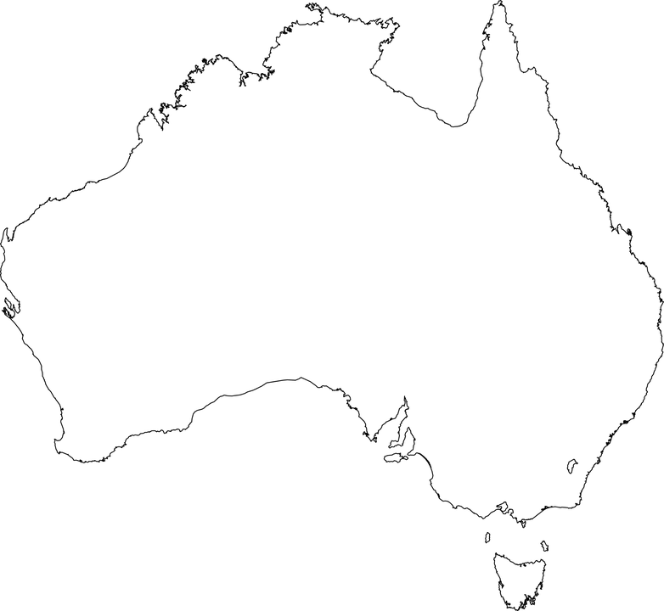

Having marked these on the map you can see that they have a big spread across the country.

1. Suggest a reason why they are grown at different months of the year at different locations?
2. Why might the spread of blueberry harvest be good for the consumers of blueberries in Australia? Think about cost, availability, and carbon footprint.

**  
  
Activity 2C**

What climate do the blueberries best grow in?

1. Look at the map of locations you have created then use the link to the Bureau of Meteorology to complete the table below. You will need to select the “Köppen – all classes map”

<https://tinyurl.com/climateblueberry>

* List all the types of climates that Blueberries are grown in.
* To what extent is location of blueberry farms and climate spatially associated?
* What other factors would be important for a location of a Blueberry farm?

2. Look at the two graphs below comparing Moorabbin Airport, Victoria and Atherton, Queensland climate data, (<http://www.bom.gov.au/climate/data/>). Use this data to answer the following question.

* Based on Qn 2B, what are the best temperatures and amounts of rainfall for blueberries to grow?

**Why Are Blueberries Important?**



**Activity 2D**

1. Using the table showing the values of blueberry production in Australia, create a bar graph to show the growth of the industry. Year on the X axis and Value on the Y axis.

|  |  |  |  |  |  |  |  |
| --- | --- | --- | --- | --- | --- | --- | --- |
| **Growing Year (Financial Year)** | 2011/12 | 2012/13 | 2013/14 | 2014/15 | 2015/16 | 2016/17 | 2017/18 |
| **Local Value of Production ($Million)** | 50 | 95 | 120 | 145 | 148 | 148 | 244 |

|  |  |  |  |  |  |  |
| --- | --- | --- | --- | --- | --- | --- |
|  |  |  |  |  |  |  |
|  |  |  |  |  |  |  |
|  |  |  |  |  |  |  |
|  |  |  |  |  |  |  |
|  |  |  |  |  |  |  |
|  |  |  |  |  |  |  |
|  |  |  |  |  |  |  |
|  |  |  |  |  |  |  |

Based upon your graph:

1. Describe the change in value of blueberry production referring to the graph created.

* What is the overall pattern – change in value $
* In what years is there most growth or loss?

1. Why might the value and production rates change from year to year?



**Activity 2E**

1. Watch this video and summarise the challenges faced with the growth of blueberries and the solutions to these problems. <https://tinyurl.com/horticulturedesert>

|  |
| --- |
| **Challenges** |
| **Solutions** |

2. Using the links below, read the article and watch the videos within it to outline the challenges faced and the solution to this problem in both Australia and America to deal with pests humanely and effeciently.

* <https://tinyurl.com/horticulturebirdproblem>
* <https://tinyurl.com/horticulturebirdproblem2>

|  |
| --- |
| **Challenges** |
| **Solutions** |

3. Netting is often used to keep birds away from the blueberries. What would be some advantages and disadvantages of this compared to the method outlined in the previous question?

4. Ever wondered how blueberries are harvested? As blueberries are grown on a bush and are easily bruised, there are a range of different ways that farmers can pick them. Research how manual vs machine picking differs and fill in the table below to list the positive and negative aspects of each.

|  |  |
| --- | --- |
| **Manual Harvesting (Hand)** | **Machine Harvesting (Automated)** |
| Pros  Cons | Pros  Cons |

**The Farming Process**



**Activity 2F**

Watch the following video and complete the missing information on the flow chart. Each of the Green diamonds is a decision box with a yes/no question. Fill out Yes or No in the correct place on each of the black arrows coming from the diamond.

* How It's Made Blueberries - <https://tinyurl.com/horticultureprocessing>

**LESSON 3**

**Cucumber and Protected Cropping**



**Activity 3A**

1. Use the information in the table to produce a bar graph to show the value of the export industry from 2009 – 2015.

|  |  |  |  |  |  |  |
| --- | --- | --- | --- | --- | --- | --- |
| **Year** | 2009/2010 | 2010/2011 | 2011/2012 | 2012/2013 | 2013/2014 | 2014/2015 |
| **Value (approx.)** | $200,000 | $250,000 | $240,000 | $350,000 | $360,000 | $330,000 |

|  |  |  |  |  |  |  |  |  |  |  |
| --- | --- | --- | --- | --- | --- | --- | --- | --- | --- | --- |
|  |  |  |  |  |  |  |  |  |  |  |
|  |  |  |  |  |  |  |  |  |  |  |
|  |  |  |  |  |  |  |  |  |  |  |
|  |  |  |  |  |  |  |  |  |  |  |
|  |  |  |  |  |  |  |  |  |  |  |
|  |  |  |  |  |  |  |  |  |  |  |
|  |  |  |  |  |  |  |  |  |  |  |
|  |  |  |  |  |  |  |  |  |  |  |
|  |  |  |  |  |  |  |  |  |  |  |

Value

Year

1. Describe the change in value of cucumber production referring to the graph created.

* What is the overall pattern – change in value $
* What year is there most growth?
* What year is there the most loss?

1. Look at the list of statements below and describe how they might link to the changes you can see in the graph. Is there any evidence of these?

* Land has been over worked and less nutrients in the soil.
* More machinery used has reduced the need for workers on farms.
* Farms have increased in size and smaller farms can’t compete.
* Climate change has reduced yield of crops
* Farmers have more land to use and have become less intensive with the use of the land.
* Diseases and /or pests have decreased the yield.

1. Below data showing the yields of a cucumber crop over a two-year period. Work out the percentage change in crop yield using the data and the formula given.

***Formula***

*A – B =* ***X*** *A = Yield 2008/9 = 26,156 Kg*

***X*** */ A =* ***Y*** *B = Yield 2013/4 = 19,227 Kg*

**Y** x 100 = % Change

**Your Answer:**

**Where Are Cucumbers Harvested?**



**Activity: 3B**

With the use of enclosed cropping, the regions where cucumber growth can take place has expanded across Australia. Add the locations listed below onto the blank Australian map and make sure the BOLTSS mapping format is implemented (Border, Orientation, Legend, Title, Scale, Source).

**Locations:**

Queensland: *Bowen, Burdekin, Bundaberg, Lockyer Valley.*

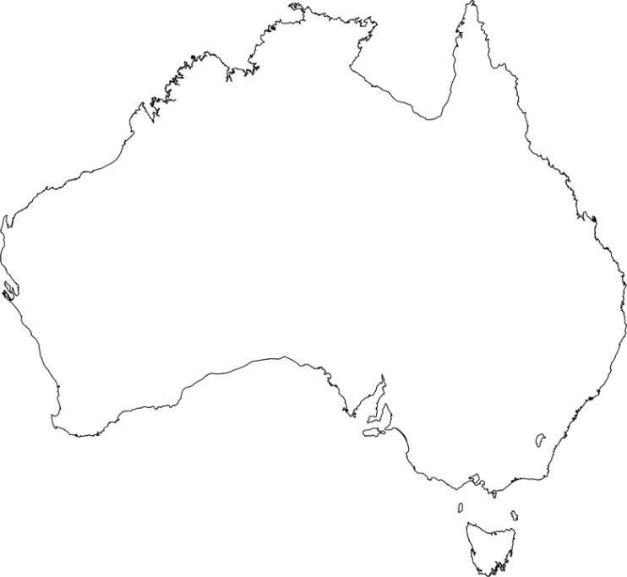  
South Australia: *North Adelaide Plains, Riverland.*

New South Wales: *Greater Sydney Basin (Central Coast to Bargo, with epicentre in Western Liverpool),*

*Mid North Coast (including Coffs Harbour, Wardell and Woolgoolga*

*Far west NSW centred in Gol Gol (adjacent to Sunraysia district of Vic*

Victoria: *Sunraysia, Melbourne Metro.*

Western Australia: *Geraldton, Metro outer areas.*

Northern Territory: *Humpty Doo.*

<https://www.tridge.com/guides/cucumber/AU>

**How Are Growing Conditions Of Cucumbers Controlled?**



**Activity 3C**

Watch the following video that focusses on a New South Wales cucumber farm that has embraced a more technological approach to farming. Answer the questions about the video.   
  
<https://tinyurl.com/horticulutreglasshouse>

1. Why do you think they have to suit up in the greenhouse?
2. What advantages are mentioned with regard to using a greenhouse and not an open field?
3. What natural ways are used to reduce flies and mosquitoes?
4. What would be a benefit of growing multiple varieties of cucumbers?
5. Reflect on the video:

* Did the process seem to use a lot of people in the system?
* What did the greenhouse look like?
* What were the crops being grown in?
* What would be the main costs of a farming system like this?

6. You can find the location of the farm by searching the following G.P.S coordinates:

* -33.32980717855362, 151.23758133316568
* Search for this in Google Earth Pro. At this site you can see a satellite image and see how the farm has expanded from 2017. The new glass house is still not been added to satellite mapping.
* Use the historical image icon to look back at the different stages of the farm’s growth. You can also use measuring tools to look at the size of the structures and the distance to nearby markets/settlements for labour.

* Answer these questions about the satellite image:

1. List any observations you make from comparing the images. Zoom out and look at the region surrounding the farm. Consider new structures, irrigation, land use around structures, distance from towns, size of farm.
2. Look at the following link of the new glasshouse featured in the video. Read through the website and list the technology used within the glasshouse to control growth conditions. <https://familyfreshfarms.com.au/the-glasshouse/>
3. Choose one of these features and explain how it controls the growing condition.
4. Can you work out from the image gallery where the new glasshouse is located on the farm? <https://familyfreshfarms.com.au/gallery/>

**LESSON 4**

**The Future Of Horticulture**

**  
  
Activity 4A**

**The use of drones in agriculture**

1. Look at the 2 videos linked below. Both videos show how drones are being used in agriculture to improve farming efficiency. Complete the activities once you have watched both videos.

* <https://tinyurl.com/dronehorticulture1>
* <https://tinyurl.com/dronehorticulture2>

2. Fill in the benefits within the appropriate part of the Venn diagram. If you can think of additional impacts not mentioned on the video, then you should add these as well.

* Social Impacts – Try and look at how people are impacted by the drone’s use.
* Economic Impacts – Listen out for how this may impact the amount of money either spent or made on the use of the drones.
* Environmental Impacts – How do you think the environment of the farmland as well as the surrounding area was impacted? This could be both positive and negative.

**The Rise In Hydroponics**



**Activity 4B**

1. Read the following article and video that look at a modern approach to hydroponics in an urban environment. The site used for growing crops is a brownfield location (an area that was built on previously).

* <https://tinyurl.com/horticulturehydroponics>
* <https://tinyurl.com/horticulturehydroponics2>

2. Answer the following questions based on the article.

1. What was the land used for previously and what benefits does this bring by changing its use?
2. What was a key goal of the founding members of Thomas and Myers? Why did they see a need to set

up this enterprise?

1. What part of the system is highlighting as a high economic cost?
2. Why might some environmentalists have an issue with the project?
3. What environmental benefits does is mention as part of the “sustainable approach”?
4. What are the social impacts of the project within the local community?
5. In the first photo of the article there is a picture of the vertical garden with the salad plants stacked on top of each other. What is a benefit of doing this?

**Where Should Australia’s Agricultural Focus Be In The Future?**



**Activity 4C**

In this final activity, think about how Australia should manage its food security in the future. To do this you need to decide what you think the biggest challenge to food production is, and then establish the best way to solve this. You may choose one of the suggestions below as your answer or you may make up your own mind. They are not matched up and are meant just to get you thinking.

a) Using the information you collect, write a 500-word report that discusses your chosen problem. You should include the positive and negative aspects when presenting your ideas.

|  |  |
| --- | --- |
| **Problems Facing Australia** | **Possible Solutions** |
| Climate Change causing extreme weather events making crop growth difficult, (droughts, flooding, cyclones, bushfires) | Drone use on farms |
| Population Growth leading to a shortage of food. | Hydroponics |
| Land Degradation due to intense farming reducing fertility of land and crop yields. | Organic Farming |
| Cheaper Imports from other countries means demand for Australian grown crops is too low. | Urban Farms |
| Alien Invasion from pests, diseases and weeds makes farming inefficient. | Satellite |
| Shortage of labour as more people move to cities to work. Farms will no longer have the workforce to produce the crops. | Robots, GM Crops |

**Links to help you start your research:**

* <https://tinyurl.com/horticultureurbanfarm>
* <https://tinyurl.com/horticultureurbangreen>
* <https://tinyurl.com/horticulturerobots>
* <https://preview.tinyurl.com/horticulturesatelliteimages>
* <https://preview.tinyurl.com/horticulturegmcrops>
* <https://tinyurl.com/horticultureplasticproblem>
* <https://tinyurl.com/horticulturelabourshortage>

b) Based on your chosen problem, answer these questions:

* How do you think we should address the problem you have chosen?
* How effective do you think this will be?
* Advantages and disadvantages
* How effective will this be in Australia
* Could this be used worldwide?
* Challenges faced by this.

c) Complete the table below by adding possible solutions.

|  |  |
| --- | --- |
| **Problems Facing Australia** | **Possible Solutions** |
| **Climate Change** causing extreme weather events making crop growth difficult, (droughts, flooding, cyclones, bushfires) |  |
| **Population Growth** leading to a shortage of food. |  |
| **Land Degradation** due to intense farming reducing fertility of land and crop yields. |  |
| **Cheaper Imports** from other countries means demand for Australian grown crops is too low. |  |
| **Alien Invasion** from pests, diseases and weeds makes farming inefficient. |  |
| **Shortage of labour** as more people move to cities to work. Farms will no longer have the workforce to produce the crops. |  |

**End of Unit - Reflection**

Congratulations on completing the lessons on horticulture in Australia. Hopefully you are more aware now of the very diverse industry that impacts so many people around Australia and the world, and can see how it is a constantly evolving industry looking to make the processes more efficient to benefit the environment, the people and the economy.

How much did I know about protected cropping before this unit? 1________________________10

How much do I understand now? 1________________________10

How important will protected cropping be to food security in the future? 1________________________10